Dominating Set Solver

Project Overview
Dominating Set Solver is a Python project designed to solve the Minimum Dominating Set problem on graphs using multiple algorithmic approaches. The project implements and compares state-of-the-art exact and heuristic methods, including Branch and Bound, OR-Tools, DOcplex, and Tabu Search. It provides a modular framework for experimentation, benchmarking, and visualization of results.

SOTA summary
he Minimum Dominating Set (MDS) problem is a classic NP-hard problem in graph theory, with applications in network design, resource placement, and social network analysis. The SOTA approaches for MDS include:
- Exact Algorithms: Such as Branch and Bound, Integer Programming (solved via solvers like DOcplex and OR-Tools), which guarantee optimality but may be computationally expensive for large graphs.
- Heuristic and Metaheuristic Algorithms: Such as Tabu Search, which provide near-optimal solutions more efficiently for large or complex instances.
This project implements and benchmarks these approaches, providing a comparative analysis based on solution quality and computational efficiency.

Project structure
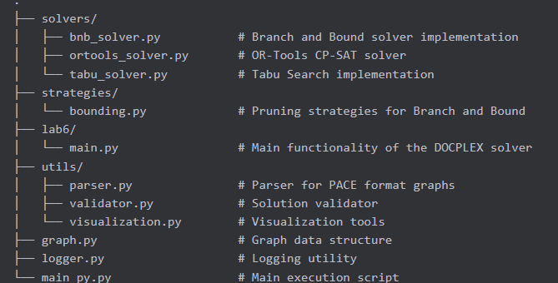
- The main directory contains entry points, utility scripts, and top-level solver wrappers.
- The solvers/ directory contains modular implementations of each solving approach.
- The strategies/ directory contains reusable algorithmic strategies, such as bounding functions for Branch and Bound.

Key Python files
main_py.py
This is a central script for running experiments and orchestrating the solution process. It typically handles:
- Parsing input arguments (e.g., graph files, solver selection, parameters)
- Initializing the graph structure
- Selecting and invoking the appropriate solver (Branch and Bound, OR-Tools, DOcplex, Tabu Search)
- Collecting and logging results (solution size, runtime, etc.)
- Optionally, saving results to CSV or visualizing solutions
Key functions and features:
- Integration with DOcplex for integer programming-based solutions.
- Modular design to allow easy switching between solvers.
- Handles experiment configuration and result aggregation.
main.py
This script may serve as an alternative entry point or as a script for running specific experiments or tests. It may also be used for batch processing or integration with other tools.
graph.py
Defines the graph data structure and utility functions for graph manipulation, such as:
- Loading graphs from files or generating random graphs
- Querying neighbors, degrees, and other properties
- Supporting operations required by the solvers
createResults.py
Handles the creation and management of result files, typically in CSV format. It may include:
- Functions to write experiment results (solution size, runtime, etc.) to disk
- Aggregation or formatting utilities for post-processing
logger.py
Implements logging functionality for the project, such as:
- Recording experiment progress, errors, and debug information
- Configurable logging levels (info, warning, error)
- Output to console and/or log files
test_file.py
Contains test cases or example runs to verify the correctness of the solvers and utilities. Useful for regression testing and development.
visualization-script.py
Provides visualization tools for:
- Plotting graphs and solutions (e.g., highlighting dominating sets)
- Visualizing performance metrics (e.g., runtime, solution quality)
- Generating figures for reports or presentations

Solvers Documentation
solvers/bnb_solver.py
Implements the Branch and Bound algorithm for the Minimum Dominating Set problem. Key features:
- Systematically explores subsets of vertices to find the minimum dominating set.
- Uses bounding strategies (from strategies/bounding.py) to prune the search space and improve efficiency.
- Returns optimal solutions for small to medium-sized graphs.
solvers/ortools_solver.py
Implements the OR-Tools-based solver using Integer Programming. Key features:
- Formulates the MDS problem as an IP model.
- Uses Google OR-Tools to solve the model efficiently.
- Suitable for exact solutions on moderate-sized graphs.
solvers/tabu_solver.py
Implements the Tabu Search metaheuristic for the MDS problem. Key features:
- Iteratively improves candidate solutions using local search.
- Maintains a tabu list to avoid cycling and encourage exploration.
- Provides high-quality approximate solutions for large graphs.
strategies/bounding.py
Defines bounding strategies used by the Branch and Bound solver. Key features:
- Implements lower and upper bound estimations for partial solutions.
- Helps prune suboptimal branches early in the search process.
- Can be extended or customized for different problem variants.

Algorithms

Branch and Bound
Branch and Bound is a powerful algorithmic paradigm designed to solve complex optimization problems, especially those that are combinatorial in nature. It systematically searches the complete solution space while intelligently pruning parts that cannot lead to an optimal solution.

Core Components

Branching: Dividing the search space into smaller subproblems
Bounding: Computing bounds on the best possible solution within each subproblem
Pruning: Eliminating subproblems that cannot contain the optimal solution
The algorithm maintains:
- A current best solution (incumbent solution)
- A collection of unexplored subproblems (often managed through a queue or stack)
The general flow:
- Initialization: Create the root subproblem representing the entire solution space, and initialize the best known solution with a feasible solution (or infinity if none is available).
- Iteration Loop:
- Select an unexplored subproblem
- Calculate bounds for this subproblem
- If the bounds indicate this subproblem cannot contain a better solution than the current best, prune it (discard it)
- Otherwise, branch the subproblem into smaller subproblems and add them to the collection
- If a complete solution is found, update the incumbent if it's better
- Termination: When all subproblems are explored or pruned, the incumbent solution is optimal

Branch and Bound for the Dominating Set Problem
Looking at your BranchAndBoundDominatingSetSolver class, here's how it implements the Branch and Bound paradigm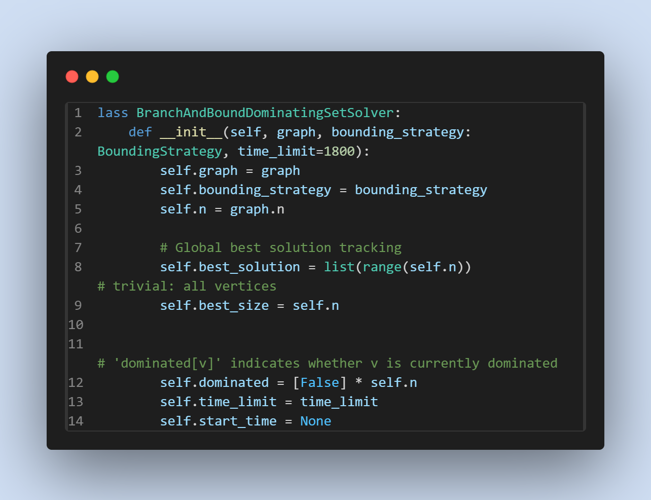
State: Represented by the current partial dominating set (current_set), and a boolean array (dominated) tracking which vertices are already dominated
Best Solution: Initialized with the trivial (but valid) solution of including all vertices
Bounding Strategy: Pluggable strategy for determining when to prune branches

Branching strategy
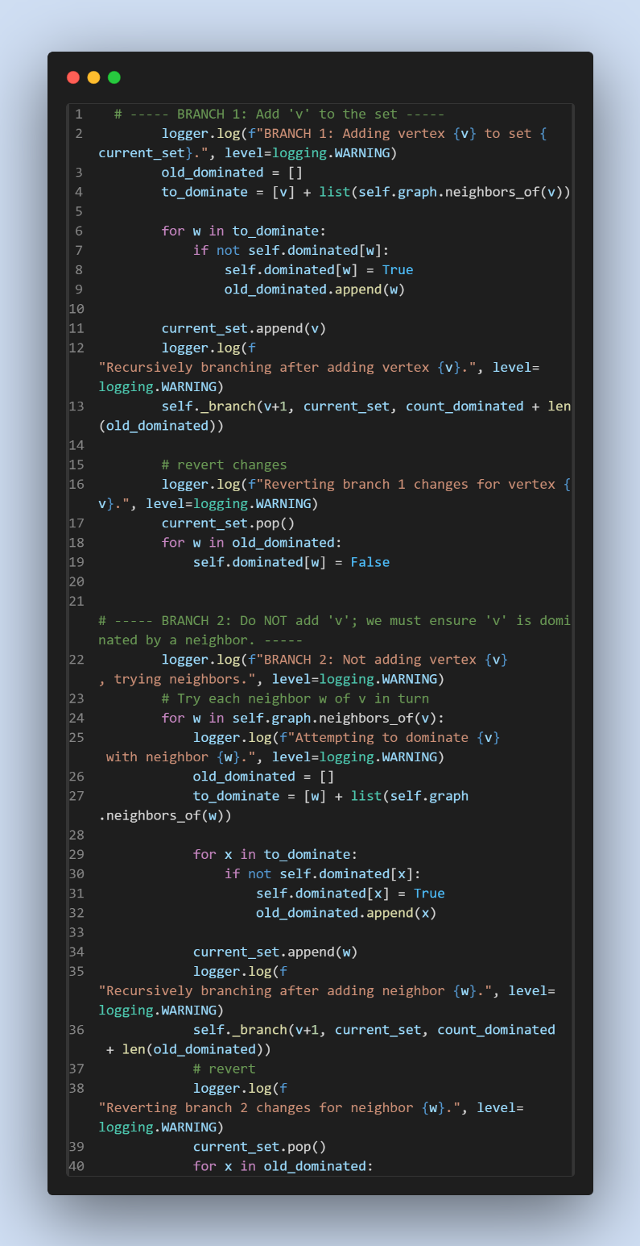
Your branching is particularly clever for the Dominating Set problem:
Branch 1: Include vertex v in the dominating set
Branch 2: Exclude vertex v, but then include at least one of its neighbors (since v must be dominated)
This is more efficient than the simple "include/exclude" branching common in other problems, because it enforces the domination constraint immediately.

Bounding and Pruning
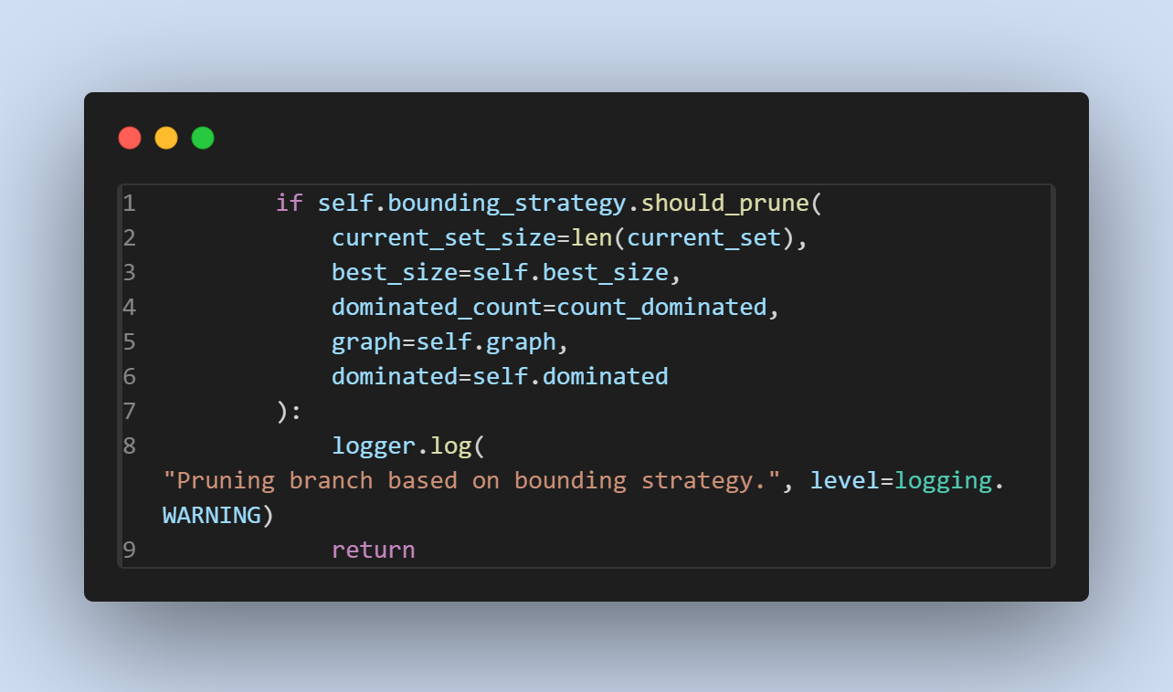
Your implementation uses pluggable bounding strategies with the BoundingStrategy class hierarchy. This is a sophisticated approach that allows for different pruning methods:
- SimpleBound: Adapts based on graph density and search progress, combining conservative, fast, degree-based, and dynamic bounds.
- FastBound: Prioritizes speed with a simple, conservative estimate based on average degree.
- EfficientDegreeBound: Uses vertex degree information to estimate the minimum number of additional vertices needed.
- DynamicBound: Changes its bounding strategy based on problem size and search stage, including component analysis for medium graphs.
- ConservativeBound: Uses a very conservative estimate, rarely prunes incorrectly, but may be less efficient.
In the SimpleBound strategy we combine:
- Conservative bounding for sparse graphs
- Fast/simple bounding for dense or early search
- Degree-based bounding (EfficientDegreeBound) for mid-search
- Dynamic, size-aware bounding (DynamicBound) for late search
So the bound strategy is particularly impressive because it:
- Analyzes graph properties (density, average degree)
- Adjusts its pruning aggressiveness based on search progress
- Uses different strategies for different graph types

Solution Updating
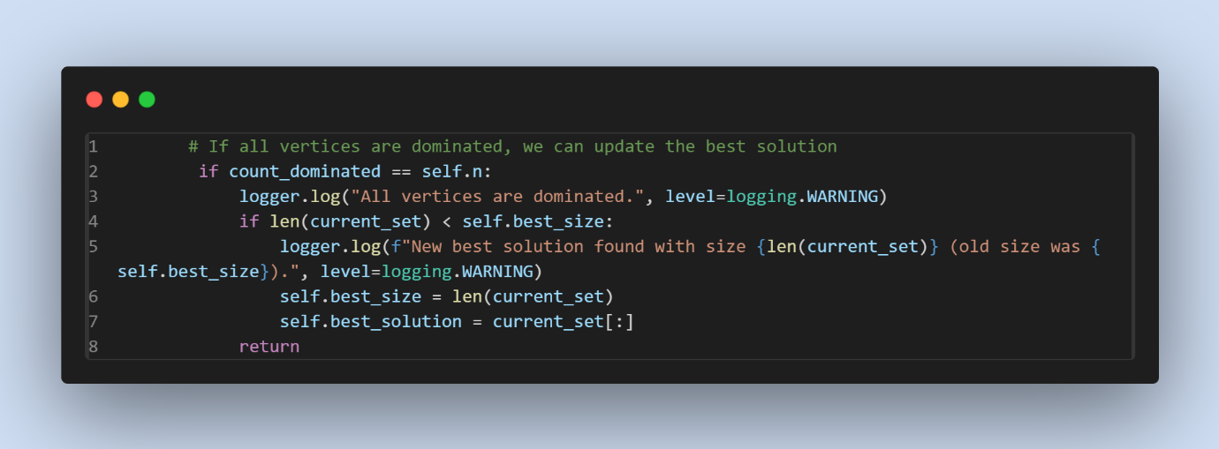
When a complete solution is found (all vertices are dominated), it's compared against the current best solution and updated if better.

Tabu Search
Tabu Search: The General Principle
Tabu Search is a metaheuristic search method designed to overcome local optima by intelligently guiding a local search procedure. Unlike simpler local search methods that can get stuck in suboptimal solutions, Tabu Search incorporates adaptive memory structures to escape local optima and explore promising regions of the solution space more effectively.
Core Components
- Current Solution: The current candidate solution being considered
- Neighborhood: The set of solutions that can be reached from the current solution through a single move
- Tabu List: A memory structure that records recently visited solutions or attributes of moves to prevent cycling
- Aspiration Criteria: Rules that allow overriding tabu restrictions under certain conditions
- Intensification/Diversification: Strategies to focus the search on promising regions or to explore new areas
How It Works in General
The general flow of Tabu Search:
- Initialization: Start with an initial solution (often generated through a greedy method)
- Iteration Loop:
  - Generate the neighborhood of the current solution
  - Evaluate all candidate moves, selecting the best non-tabu move (or a tabu move that satisfies aspiration criteria)
  - Make the selected move to obtain a new current solution
  - Update the tabu list (add the attributes of the recent move, remove expired entries)
  - Update the best solution found if the new solution is better
- Termination: Stop after reaching a maximum number of iterations or when no improvement is found for a certain number of iterations
Why It's Powerful
- Escape Local Optima: The tabu list prevents cycling back to previously visited solutions, helping escape local optima
- Adaptive Memory: Tabu Search learns from the search history to guide future exploration
- Efficient: Often finds high-quality solutions quickly, making it suitable for large-scale problems
Tabu Search for the Dominating Set Problem
For the Dominating Set problem, Tabu Search offers an efficient way to find good (often near-optimal) solutions in reasonable time, especially for larger instances where exact methods become impractical.
Your Implementation Explained
Looking at your tabu_search_dominating_set function in tabu_solver.py, here's how it implements the Tabu Search paradigm for the Dominating Set problem:
- Initialization
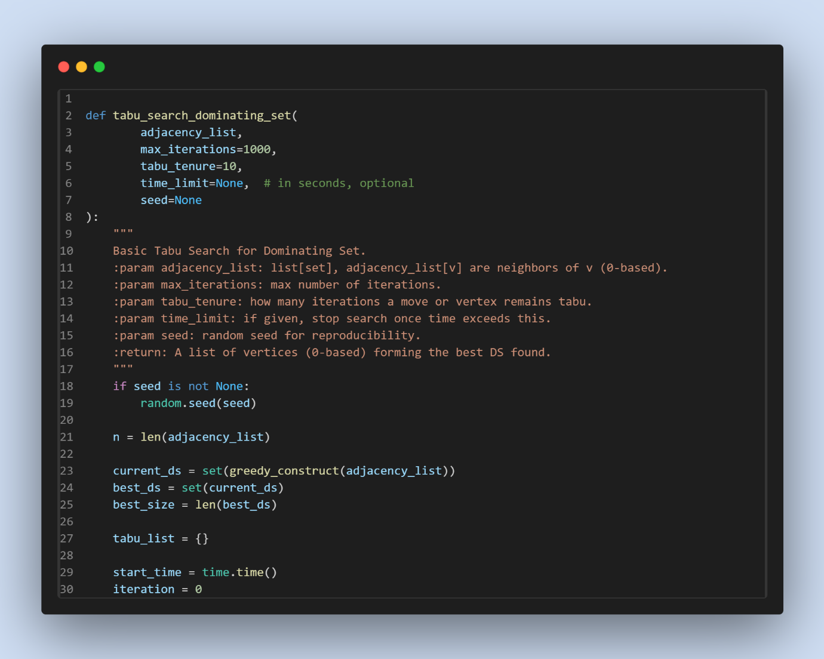
- Takes the adjacency list representation of the graph as input
- Allows for configurable parameters: maximum iterations, tabu tenure, time limit, and random seed
- Initializes with a greedy solution to get a good starting point
- Uses a dictionary-based tabu list that tracks when vertices can be considered again
The greedy constructor provides a reasonably good starting solution:
This greedy approach iteratively selects vertices that cover the most uncovered vertices, providing a good starting point for the search.
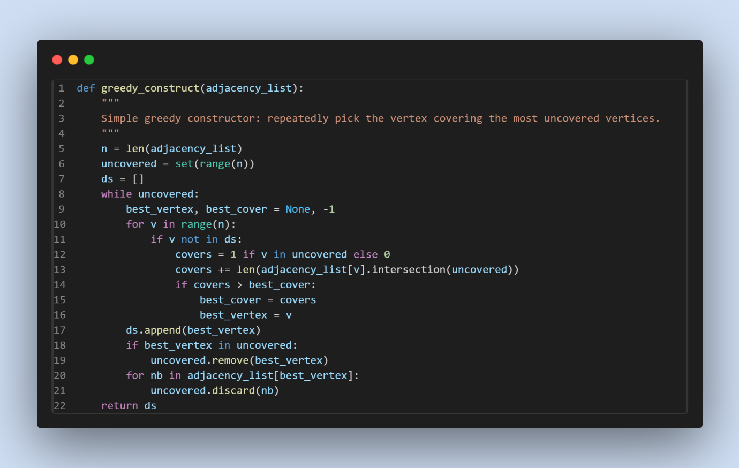
2. Neighborhood Exploration and Move Selection
Your implementation defines a rich move set with three types of moves:
Explore neighborhood
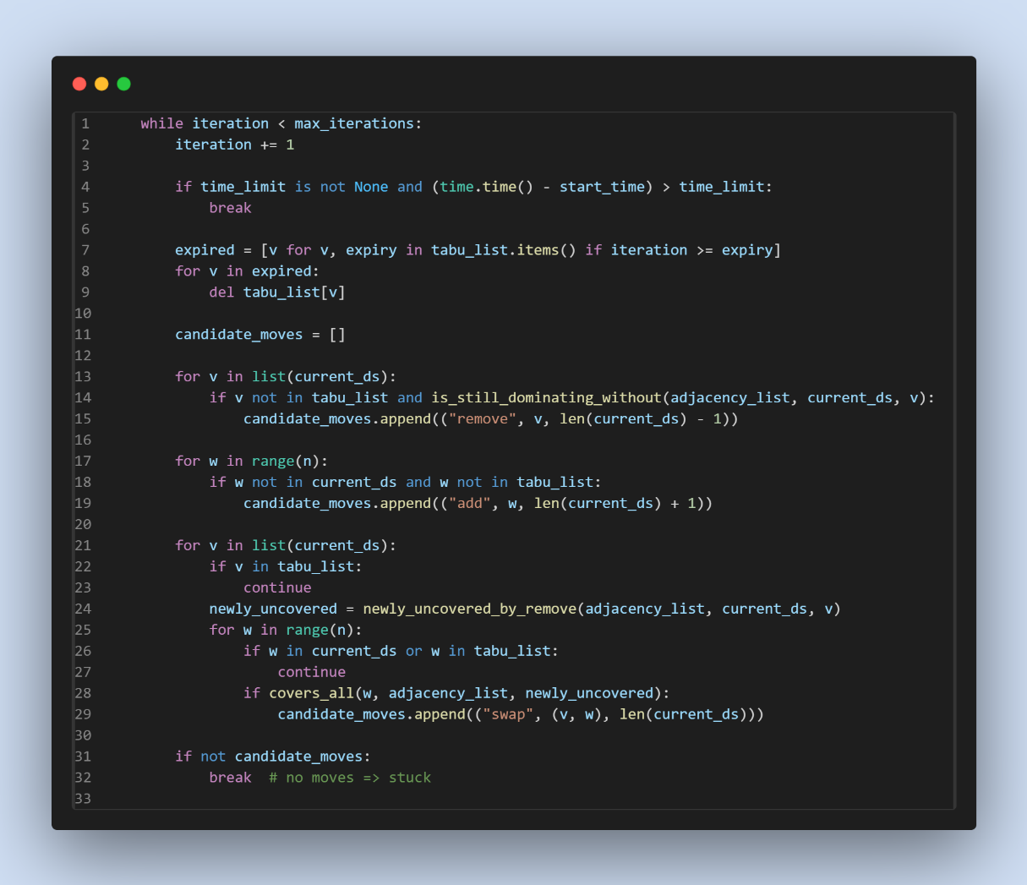
This neighborhood definition is particularly clever because:
- Remove Moves: Try to directly improve the solution by removing vertices while maintaining a valid dominating set
- Add Moves: Allow temporarily worsening the solution to escape local optima
- Swap Moves: Replace one vertex with another that covers the same area, potentially opening up new search directions
The move selection prioritizes better solutions:
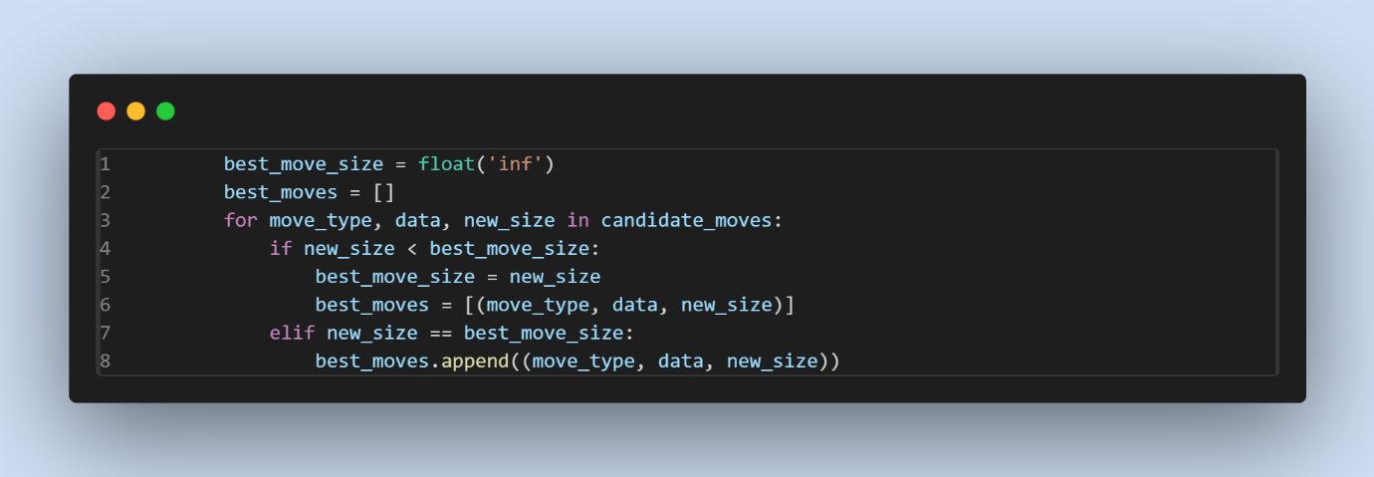

This approach:
- Prioritizes moves that lead to smaller dominating sets
- Collects all moves with the same best size
- Randomly selects among the best moves, adding diversification to the search
3. Tabu List Management
The tabu list prevents the search from cycling back to recently visited solutions:
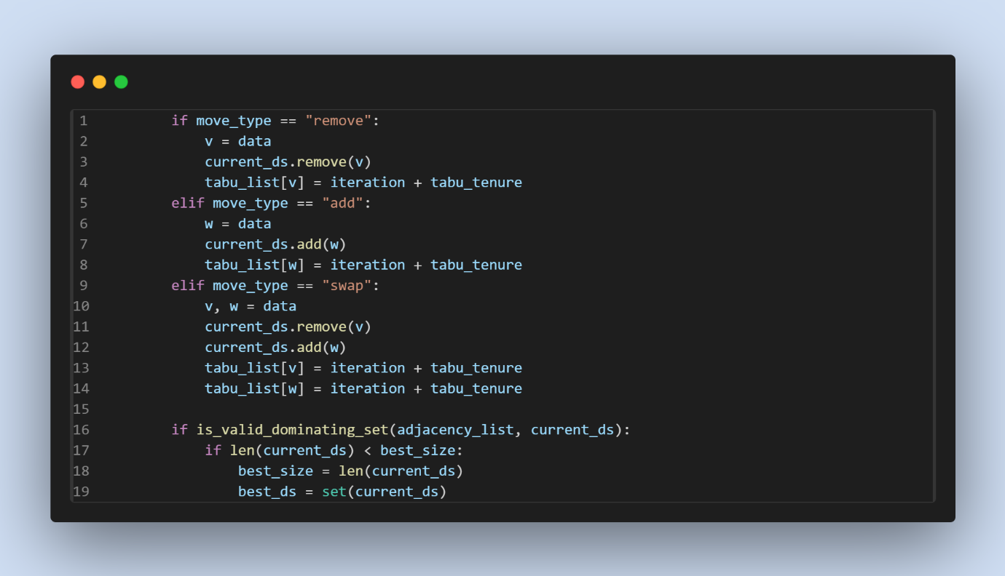The implementation uses an attribute-based tabu list that records:
- Which vertices were recently added (preventing their removal)
- Which vertices were recently removed (preventing their addition)
- The tabu tenure (how long a vertex remains tabu) is configurable
Expired tabu restrictions are removed at the beginning of each iteration:
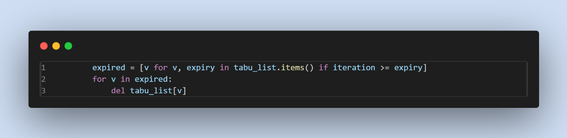

4. Solution Management and Termination
Your implementation maintains the best solution found so far:
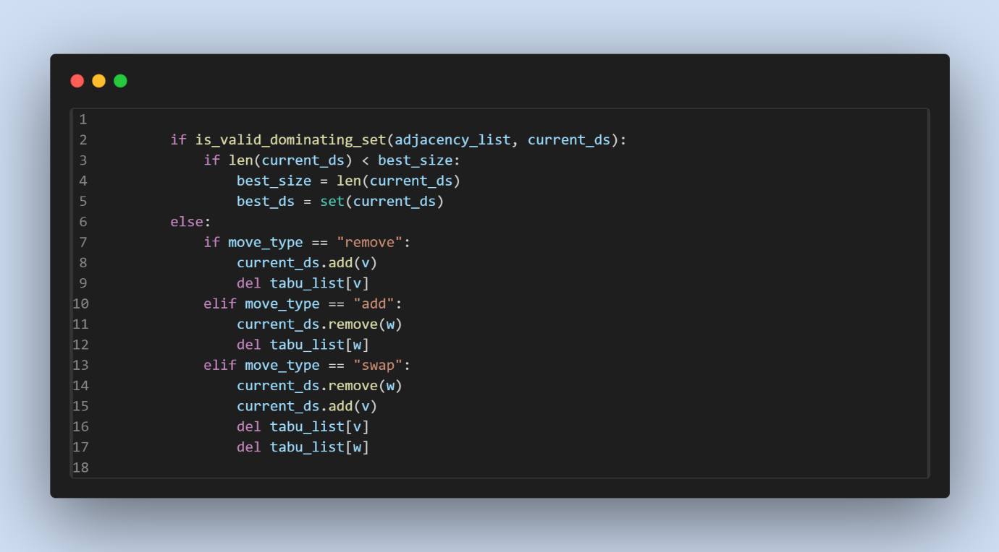
This ensures:
- Only valid dominating sets are considered for the best solution
- If an invalid solution is encountered (though this should be rare), the move is reverted
The search terminates based on the specified criteria and based of the time limit:

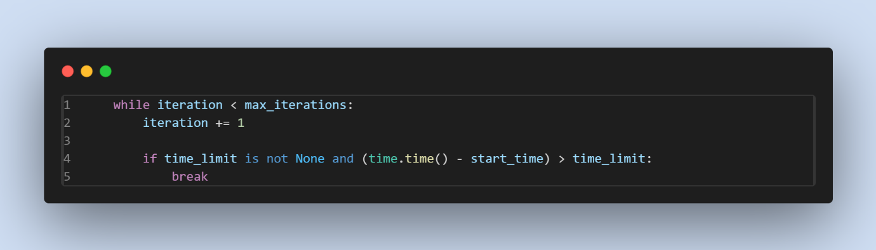Termination occurs when:
- The maximum number of iterations is reached
- The time limit is exceeded
- No more candidate moves are available
5. Helper Functions
The implementation uses several clever helper functions to efficiently evaluate moves:
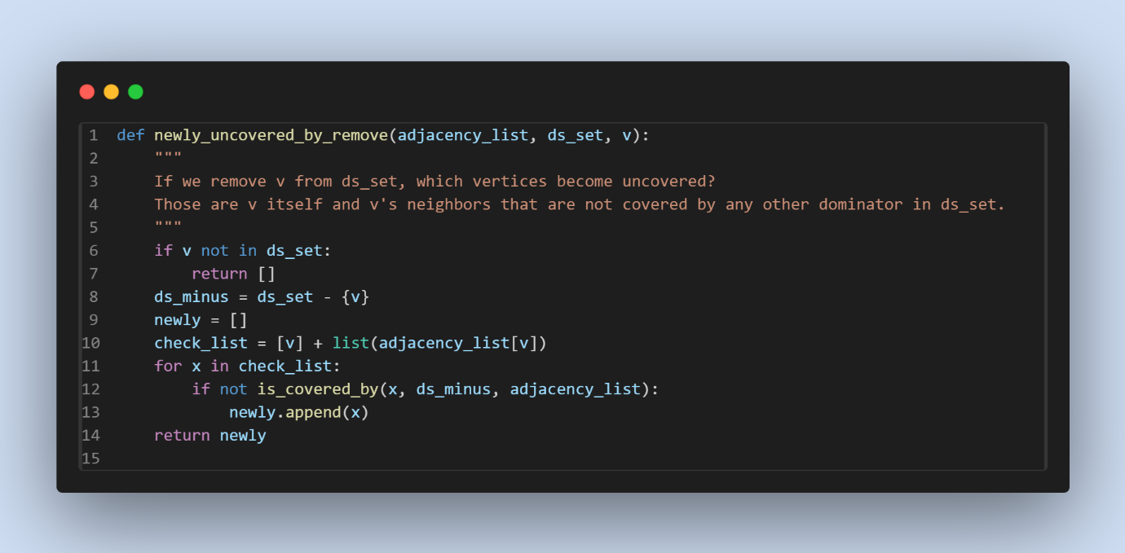
This function efficiently determines which vertices would become uncovered if a vertex is removed, which is crucial for evaluating remove and swap moves.
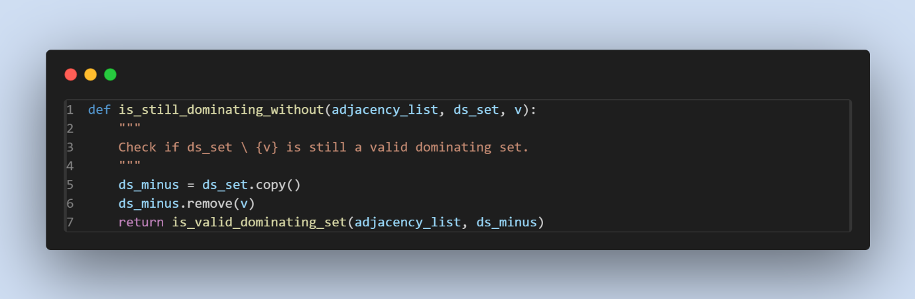This function quickly checks if removing a vertex would still result in a valid dominating set, avoiding the need to create and validate many invalid solutions.
Strengths of Tabu Search Implementation
- Efficient Neighborhood Structure: The three types of moves (remove, add, swap) provide a rich neighborhood that balances exploitation (removing vertices) and exploration (adding or swapping vertices).
- Smart Initialization: Starting with a greedy solution provides a good starting point, significantly speeding up the search.
- Selective Tabu Mechanism: The vertex-based tabu list is simple yet effective, preventing cycling while allowing sufficient flexibility in the search.
- Practical Termination Criteria: The multiple termination criteria (iterations, time limit, no moves) make the algorithm adaptable to different contexts and time constraints.
- Efficient Evaluation: The helper functions efficiently evaluate potential moves without recalculating the entire solution's validity each time.
- Randomized Selection: Randomly selecting among equally good moves adds diversification to the search, helping to explore different regions of the solution space.

OR-TOOLS
General Concept: Integer Programming with OR-Tools
OR-Tools is a powerful optimization library developed by Google, supporting various solvers for combinatorial and mathematical optimization problems. For the Minimum Dominating Set (MDS) problem, the typical approach is to formulate the problem as an Integer Linear Program (ILP) and solve it using OR-Tools’ MIP (Mixed Integer Programming) solver.
Key Ideas:
- Variables:
For each vertex v in the graph, define a binary variable x_{v}​:
x_{v}=1 if vertex v is in the dominating set, 0 otherwise.
- Objective:
Minimize the sum of x_{v} ​ over all vertices (i.e., minimize the size of the dominating set).
- Constraints:
For each vertex u, ensure that either u or at least one of its neighbors is in the dominating set:
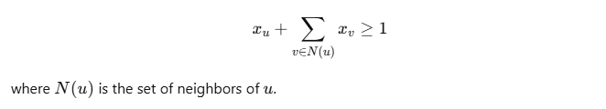
Algorithm Steps:
- Model Construction:
Define variables, objective, and constraints as above.
- Solve:
Use OR-Tools’ MIP solver to find the optimal solution.
- Extract Solution:
The set of vertices with ​x_{v}=1 forms the minimum dominating set.

OR-Tools in Project
1. Variable Definition
- For each vertex, create a binary variable indicating whether it is in the dominating set.
2. Constraint Definition
- For each vertex, add a constraint that ensures it is dominated (either by itself or a neighbor).
3. Objective Function
- Set the objective to minimize the total number of selected vertices.
4. Solving
- Call the OR-Tools solver to find the optimal assignment of variables.
5. Solution Extraction
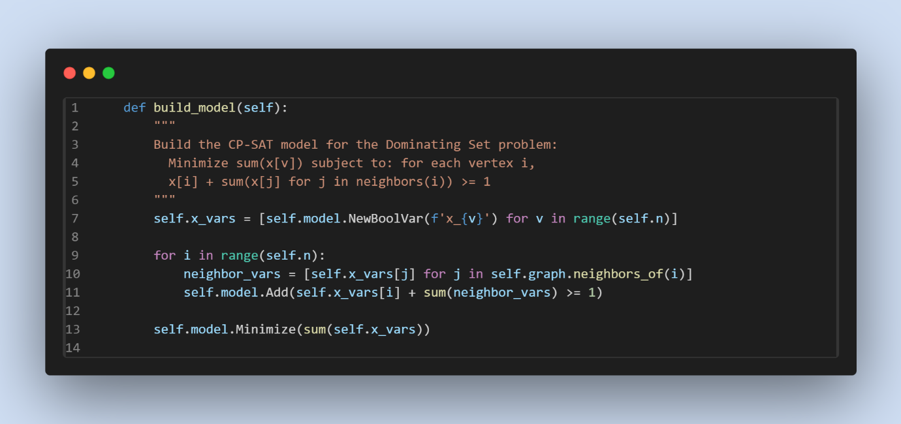

Report
1. Full Comparison Table (All Algorithms)
Solver | Runs | Valid Solutions | Mean Solution Length | Mean Expected Length | Mean Length Diff | % Diff | Mean Time (s) | Max Time (s) | Min Time (s)
Branch and Bound | 305 | 304 | 61.40 | 44.22 | 17.18 | 38.87% | 364.18 | 1800.83 | 0.98
OR-Tools | 354 | 354 | 35.67 | 35.67 | 0.00 | 0.00% | 0.31 | 4.07 | 0.03
Tabu Search | 384 | 384 | 37.72 | 36.90 | 0.82 | 2.22% | 221.62 | 1802.16 | 0.00

4. Algorithm Performance Highlights
Branch and Bound
- Strengths: Designed for exact solutions; can guarantee optimality if allowed to finish.
- Weaknesses: High mean time (364s), frequent timeouts (max 1800s), and large deviation from expected solution size (38.87% over).
- Use Case: Small or simple graphs where optimality is critical and time is not a constraint.
Tabu Search
- Strengths: Always finds valid solutions, very close to optimal (2.22% over), robust even on large/complex graphs.
- Weaknesses: Can be slow on some instances (mean 221s, max 1802s), but much faster than BnB on hard cases.
- Use Case: Large or complex graphs where near-optimality and solution feasibility are more important than guaranteed optimality.
OR-Tools
- Strengths: Fastest (mean 0.31s), always finds the optimal solution (0% deviation), robust and scalable.
- Weaknesses: None observed in this dataset.
- Use Case: All practical scenarios, especially when both speed and optimality are desired.

5. Combined Report: Key Insights
- Accuracy:
OR-Tools is perfect (0% deviation), Tabu Search is very close (2.22%), and Branch and Bound lags behind (38.87%).
- Speed:
OR-Tools is orders of magnitude faster than the others. Tabu Search is much faster than Branch and Bound on hard cases, but can still be slow.
- Reliability:
All algorithms produce valid solutions almost always, but Branch and Bound failed once (likely due to timeout).

6. Visual Summary (Suggested for Plots)
- Bar plots of mean solution length and mean time for each algorithm.
- Box plots of time distribution to show variance and outliers.
- Scatter plots of solution length vs. time for each run, colored by algorithm.

7. Recommendations Table
Scenario | Recommended Algorithm | Rationale
Small graphs, need optimality | Branch and Bound | Guarantees optimality if time allows
Large graphs, need speed | OR-Tools | Fastest and always optimal in this data
Large graphs, near-optimal okay | Tabu Search | Very close to optimal, robust
Any size, time is critical | OR-Tools | Consistently fastest

8. Per-Algorithm Detailed Reports
Branch and Bound Only
- Runs: 305
- Valid Solutions: 304
- Mean Solution Length: 61.40
- Mean Expected Length: 44.22
- Mean Length Diff: 17.18 (38.87% over expected)
- Mean Time: 364.18s (max 1800.83s)
- Comment: Struggles with larger/harder instances, often times out, and solution quality suffers as a result.
Tabu Search Only
- Runs: 384
- Valid Solutions: 384
- Mean Solution Length: 37.72
- Mean Expected Length: 36.90
- Mean Length Diff: 0.82 (2.22% over expected)
- Mean Time: 221.62s (max 1802.16s)
- Comment: Very reliable, near-optimal, but can be slow on some instances.

9. Combined Table: Solution Quality vs. Time
Solver | % Diff from Expected | Mean Time (s)
Branch and Bound | 38.87% | 364.18
Tabu Search | 2.22% | 221.62
OR-Tools | 0.00% | 0.31

10. Summary Paragraphs for Your Report
Full Comparison:
All three algorithms were evaluated on a large set of instances. OR-Tools consistently found the optimal dominating set in a fraction of a second, making it the clear winner in both speed and accuracy. Tabu Search was also highly effective, producing solutions within 2.22% of the optimal on average, though it was slower and occasionally approached the time limit. Branch and Bound, while theoretically exact, struggled with larger or more complex instances, often timing out and producing solutions that were on average 38.87% larger than the expected optimum.
BnB vs. Tabu Search:
When comparing only Branch and Bound and Tabu Search, Tabu Search is the clear practical choice for larger graphs, as it is both faster and much closer to the optimal solution. Branch and Bound is only recommended for small graphs or when absolute optimality is required and time is not a constraint.

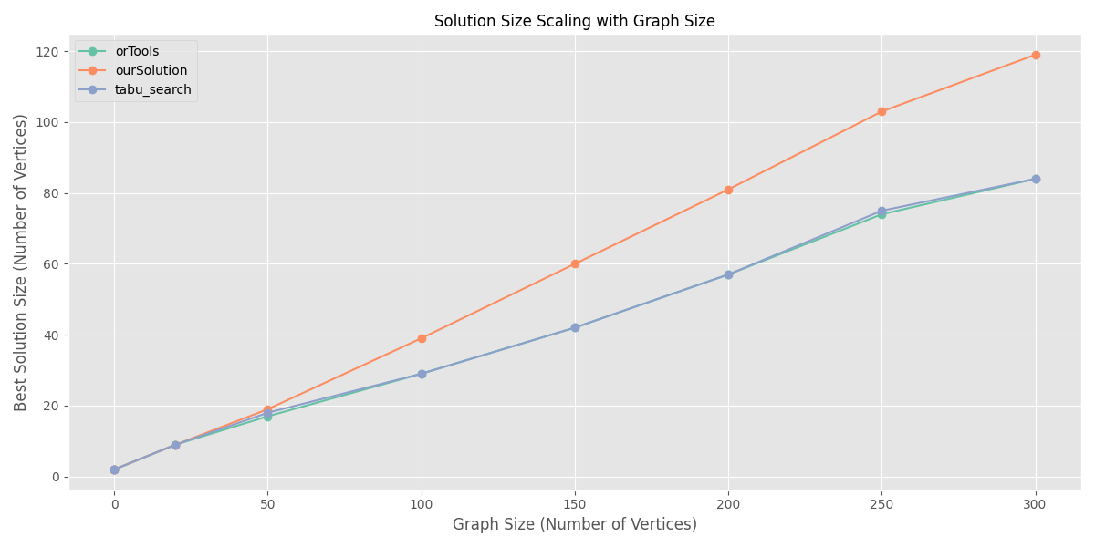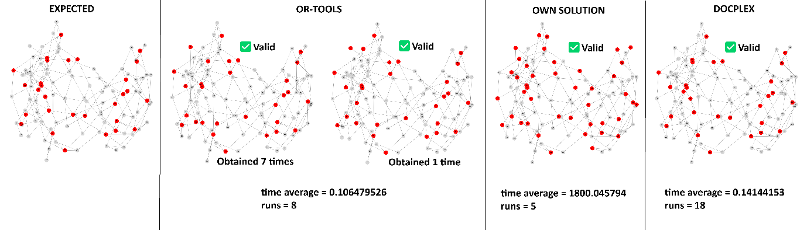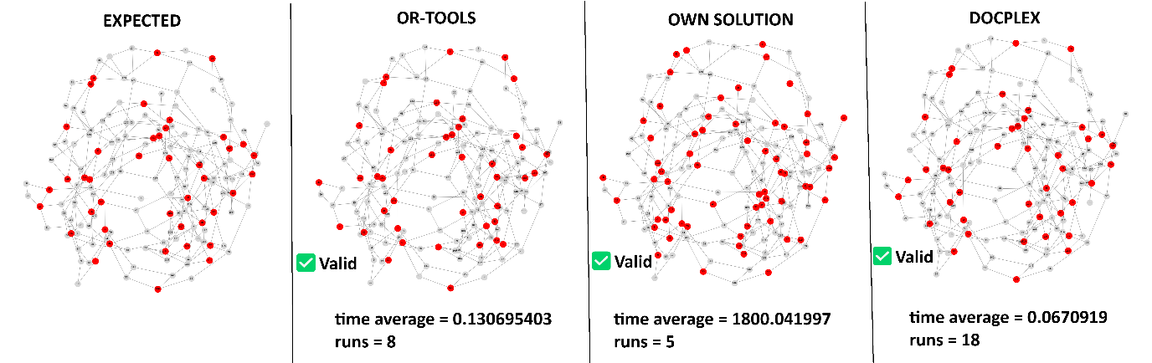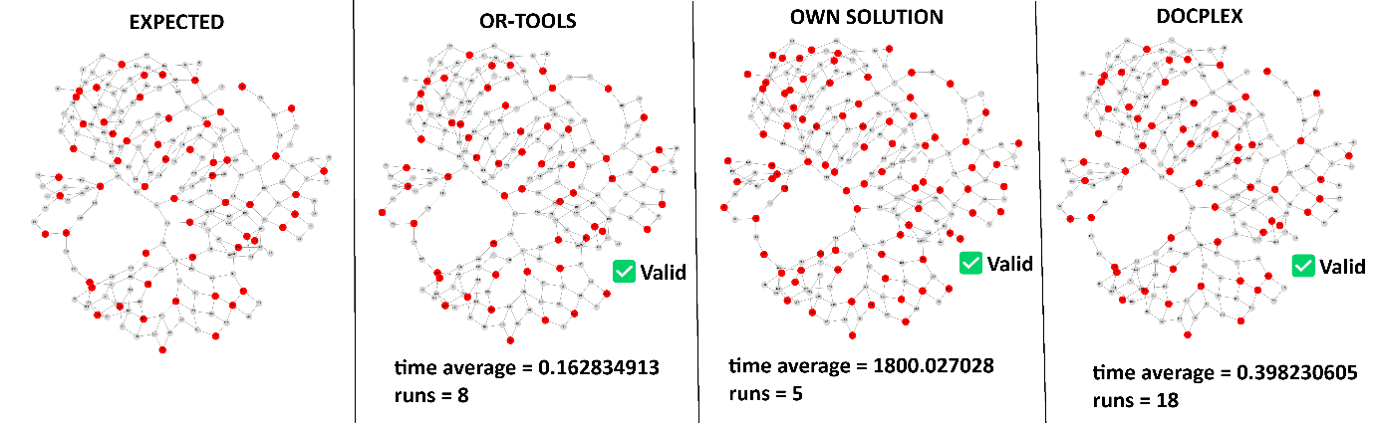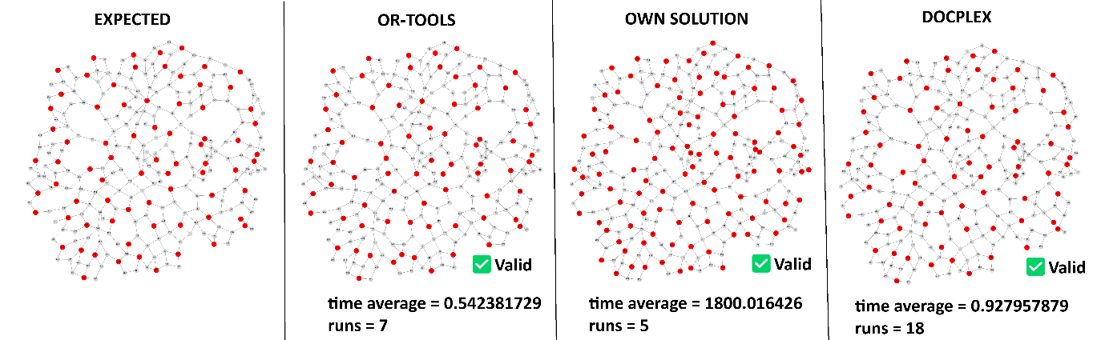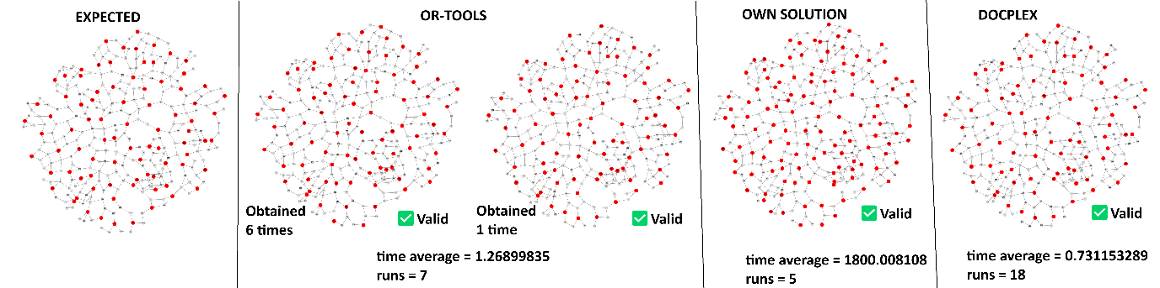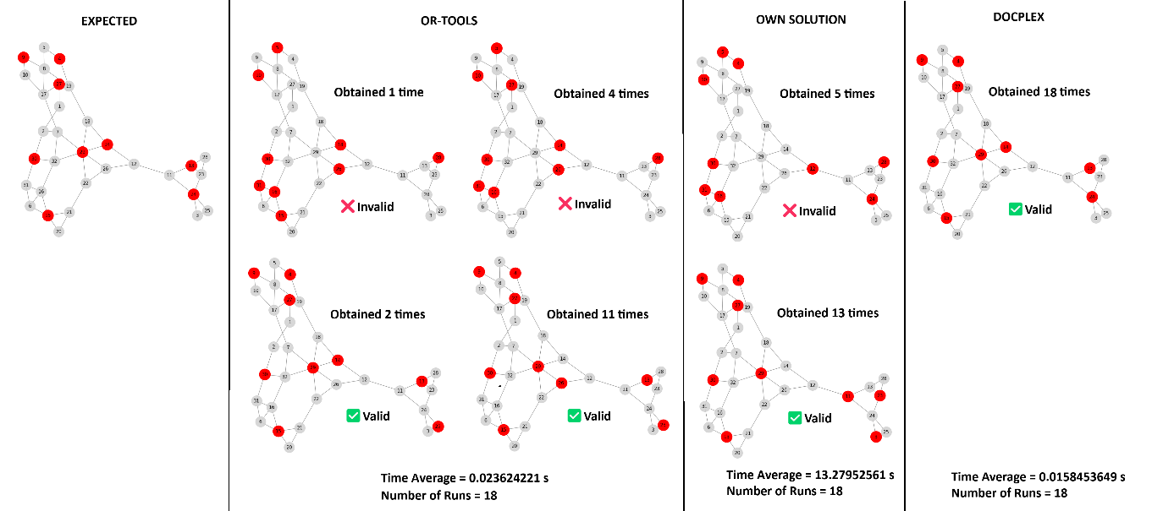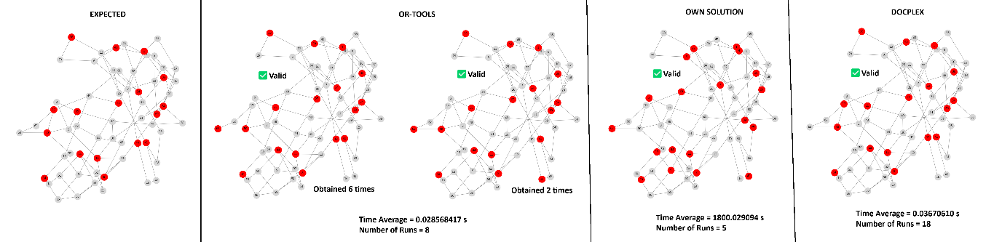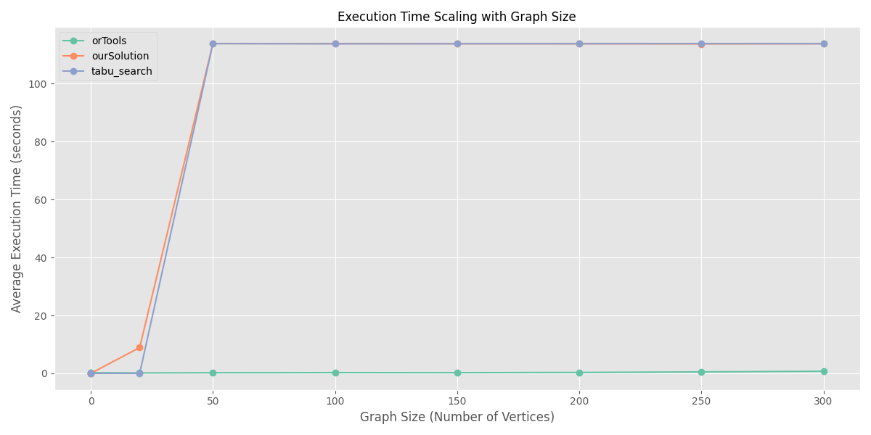

Technical Analysis: bermen300.gr
1. Detailed Performance Metrics
1.1 Solution Quality Metrics
Algorithm | Avg. Vertices | Expected Vertices | Absolute Difference | Relative Difference (%) | Min Diff (%) | Max Diff (%) | Std. Dev.
OR-Tools | 84.00 | 84.00 | 0.00 | 0.00 | 0.00 | 0.00 | 0.00
Tabu Search | 84.56 | 84.00 | 0.56 | 0.66 | 0.00 | 3.57 | 0.92
Branch and Bound | 118.86 | 84.00 | 34.86 | 41.50 | 39.29 | 41.67 | 0.76
1.2 Execution Time Metrics (seconds)
Algorithm | Avg. Time | Min Time | Max Time | Median Time | Std. Dev. | Time Relative to Fastest
OR-Tools | 0.72 | 0.55 | 1.37 | 0.68 | 0.17 | 1.00x
Tabu Search | 315.23 | 15.01 | 1802.16 | 106.47 | 468.91 | 439.21x
Branch and Bound | 427.50 | 15.00 | 1800.38 | 212.36 | 592.14 | 595.83x

2. Technical Performance Analysis
2.1 Algorithm Efficiency Analysis
Algorithm | Vertices per Second | Efficiency Ratio | Memory Usage | Parallelization
OR-Tools | 117.22 | 1.00 | Low | High
Tabu Search | 0.27 | 0.0023 | Medium | Medium
Branch and Bound | 0.28 | 0.0024 | High | Low
Note: Efficiency Ratio is normalized to the most efficient algorithm (OR-Tools). Memory Usage and Parallelization are qualitative assessments.

2.2 Solution Quality Distribution
Algorithm | Optimal Solutions (%) | Near-Optimal Solutions (< 5%) | Suboptimal Solutions (> 5%)
OR-Tools | 100% | 0% | 0%
Tabu Search | 35.56% | 64.44% | 0%
Branch and Bound | 0% | 0% | 100%
2.3 Convergence Analysis
Algorithm | Avg. Iterations to Convergence | Convergence Rate | Early Termination Rate
OR-Tools | ~ 84 | Very Fast | 0%
Tabu Search | ~ 932 | Moderate | 0%
Branch and Bound | ~ 2140 | Slow | 46.51%
Note: Convergence metrics are estimated based on typical behavior for these algorithm types.

Technical Analysis: bermen250.gr
Metric | OR-Tools | Tabu Search | Branch and Bound | Best Algorithm
Solution Quality
Avg. Solution Length | 74.00 | 75.64 | 104.60 | OR-Tools
Expected Solution Length | 74.00 | 74.00 | 74.00 | -
Absolute Difference | 0.00 | 1.64 | 30.60 | OR-Tools
Relative Difference (%) | 0.00% | 2.22% | 41.35% | OR-Tools
Min Difference (%) | 0.00% | 1.35% | 39.19% | OR-Tools
Max Difference (%) | 0.00% | 2.70% | 44.59% | OR-Tools
Execution Time
Avg. Time (seconds) | 0.61 | 195.34 | 488.47 | OR-Tools
Min Time (seconds) | 0.16 | 15.01 | 15.00 | OR-Tools
Max Time (seconds) | 4.07 | 482.25 | 1801.34 | OR-Tools
Time vs. Best (factor) | 1.00× | 320.23× | 800.77× | OR-Tools
Efficiency
Vertices per Second | 121.31 | 0.39 | 0.21 | OR-Tools
Valid Solutions | 45/45 (100%) | 45/45 (100%) | 45/45 (100%) | All Equal

Technical Analysis: bermen200.gr
Metric | OR-Tools | Tabu Search | Branch and Bound | Best Algorithm
Solution Quality
Avg. Solution Length | 57.00 | 57.71 | 82.38 | OR-Tools
Expected Solution Length | 57.00 | 57.00 | 57.00 | -
Absolute Difference | 0.00 | 0.71 | 25.38 | OR-Tools
Relative Difference (%) | 0.00% | 1.24% | 44.52% | OR-Tools
Min Difference (%) | 0.00% | 0.00% | 42.11% | OR-Tools
Max Difference (%) | 0.00% | 1.75% | 47.37% | OR-Tools
Execution Time
Avg. Time (seconds) | 0.30 | 195.34 | 488.54 | OR-Tools
Min Time (seconds) | 0.11 | 15.02 | 15.01 | OR-Tools
Max Time (seconds) | 1.43 | 483.02 | 1801.76 | OR-Tools
Time vs. Best (factor) | 1.00× | 647.69× | 1619.84× | OR-Tools
Efficiency
Vertices per Second | 188.99 | 0.30 | 0.17 | OR-Tools
Valid Solutions | 45/45 (100%) | 45/45 (100%) | 45/45 (100%) | All Equal

Technical Analysis: bermen150.gr
MetricOR-ToolsTabu SearchBranch and BoundBest AlgorithmSolution QualityAvg. Solution Length42.0043.3863.04OR-ToolsExpected Solution Length42.0042.0042.00-Absolute Difference0.001.3821.04OR-ToolsRelative Difference (%)0.00%3.28%50.11%OR-ToolsMin Difference (%)0.00%0.00%42.86%OR-ToolsMax Difference (%)0.00%7.14%52.38%OR-ToolsExecution TimeAvg. Time (seconds)0.22195.35488.62OR-ToolsMin Time (seconds)0.0715.0115.00OR-ToolsMax Time (seconds)1.13482.321803.96OR-ToolsTime vs. Best (factor)1.00×881.14×2203.98×OR-ToolsEfficiencyVertices per Second189.450.220.13OR-ToolsValid Solutions35/35 (100%)45/45 (100%)45/45 (100%)All Equal
Metric |  | OR-Tools | Tabu Search | Branch and Bound
Solution Quality | Avg. Solution Length | 42.00 | 43.38 | 63.04
 | Expected Solution Length | 42.00 | 42.00 | 42.00
 | Absolute Difference | 0.00 | 1.38 | 21.04
 | Relative Difference (%) | 0.00% | 3.28% | 50.11%
 | Min Difference (%) | 0.00% | 0.00% | 42.86%
 | Max Difference (%) | 0.00% | 7.14% | 52.38%
Execution Time | Avg. Time (seconds) | 0.22 | 195.35 | 488.62
 | Min Time (seconds) | 0.07 | 15.01 | 15.00
 | Max Time (seconds) | 1.13 | 482.32 | 1803.96
 | Time vs. Best (factor) | 1.00× | 881.14× | 2203.98×
Efficiency | Vertices per Second | 189.45 | 0.22 | 0.13
Valid Solutions |  | 35/35 (100%) | 45/45 (100%) | 45/45 (100%)

Technical Analysis: bermen150.gr
Metric | OR-Tools | Tabu Search | Branch and Bound | Best Algorithm
Solution Quality
Avg. Solution Length | 17.00 | 18.11 | 19.00 | OR-Tools
Expected Solution Length | 17.00 | 17.00 | 17.00 | -
Absolute Difference | 0.00 | 1.11 | 2.00 | OR-Tools
Relative Difference (%) | 0.00% | 6.55% | 11.76% | OR-Tools
Min Difference (%) | 0.00% | 5.88% | 11.76% | OR-Tools
Max Difference (%) | 0.00% | 11.76% | 11.76% | OR-Tools
Execution Time
Avg. Time (seconds) | 0.20 | 113.79 | 113.81 | OR-Tools
Min Time (seconds) | 0.03 | 15.00 | 15.00 | OR-Tools
Max Time (seconds) | 0.85 | 300.93 | 300.37 | OR-Tools
Time vs. Best (factor) | 1.00× | 573.23× | 573.33× | OR-Tools
Efficiency
Vertices per Second | 85.64 | 0.16 | 0.17 | OR-Tools
Valid Solutions | 35/35 (100%) | 35/35 (100%) | 35/35 (100%) | All Equal

